
Subject: Programming with Java
ASSIGNMENT No : 5
TITLE :Develop a Java application demonstrating the use of ArrayList, Vector, and StringBuffer for dynamic data storage, management, and string manipulation.
Name:Avdhoot Mohite Class:CSE A3
PRN:25070122056 Batch:25-29
Problem Statement
Develop a Java application demonstrating the use of ArrayList, Vector, and StringBuffer for dynamic data storage, management, and string manipulation.
Learning Objectives
To implement dynamic data storage and string manipulation using ArrayList, Vector, and StringBuffer.
Theory
ArrayList and Vector are dynamic array implementations provided by the Java Collections Framework. ArrayList offers faster performance in single-threaded applications, whereas Vector provides synchronized operations for thread safety. StringBuffer is a mutable sequence of characters that allows efficient string modification without creating new objects. These classes are commonly used in applications requiring dynamic memory allocation and efficient string processing
Outcome
After completing this experiment, we learned how to use ArrayList and Vector for dynamic data storage and management, and StringBuffer for efficient string manipulation. We understood how to add, access, update, and remove elements from dynamic collections, and how StringBuffer helps in modifying strings without creating new objects. The experiment also provided practical knowledge of Java Collection Framework classes and their applications.
Conclusion:
The experiment successfully demonstrated the use of ArrayList, Vector, and StringBuffer in Java. ArrayList and Vector were used to store and manage data dynamically, while StringBuffer was used for efficient string operations. This experiment improved the understanding of Java's dynamic data structures and mutable strings, which are essential for developing efficient and flexible Java applications.
Exercise
1).Create a To-Do List application using ArrayList to store tasks and StringBuffer to display tasks.
CODE:
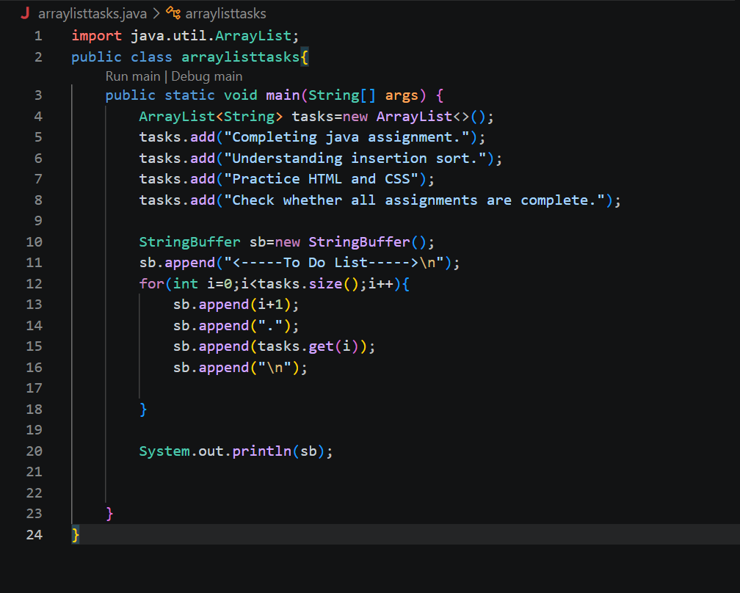

OUTPUT:
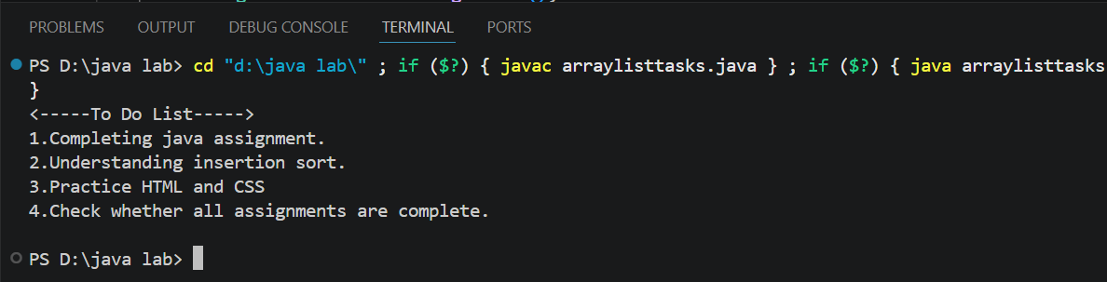

2).Create a Student Course Registration System using ArrayList to store the list of courses registered by a student and StringBuffer to generate and display the registered course list. The application should allow users to add, remove, and view registered courses
CODE:
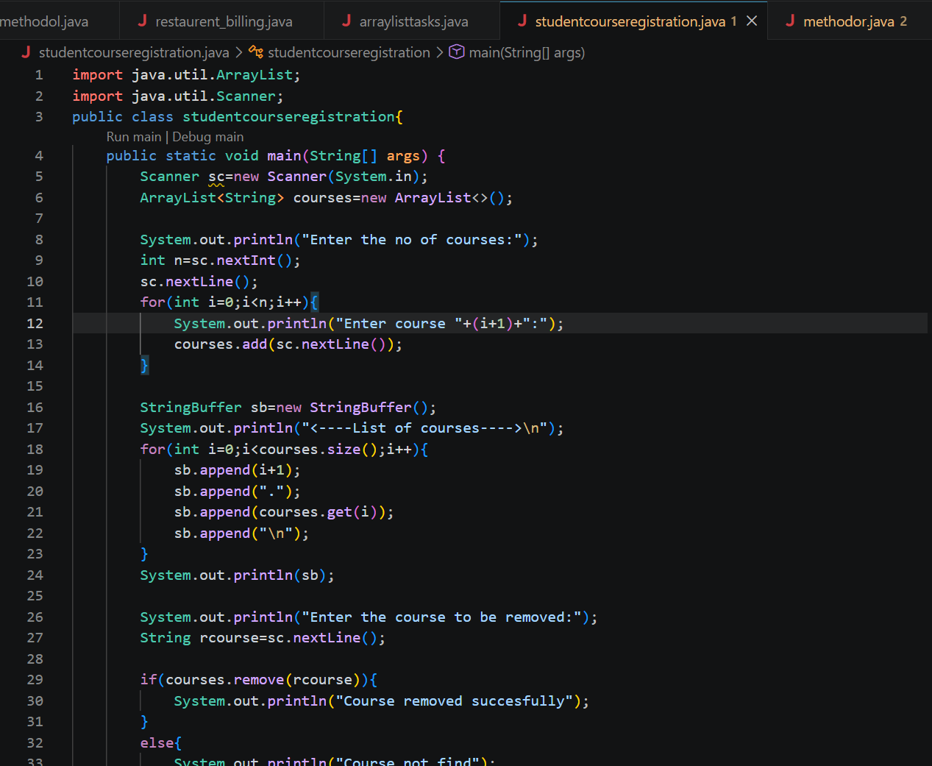
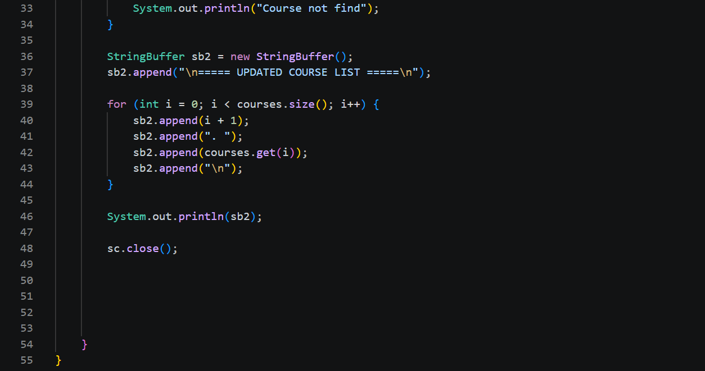

OUTPUT:
